The value of bikes & bike lanes over cars & roads
自行車與自行車道相較於汽車與道路的價值
Objective statistics over subjective opinions
客觀統計勝於主觀意見。
Showing the value of active travel using data.
利用數據展示積極出行的價值。
Statistics refer to the UK unless mentioned otherwise.
除非另有說明，統計數據均指英國。
Money & the economy
金錢與經濟
Public sector spending on roads in the United Kingdom has been over 12 billion British pounds each year since 2021.
自2021年以來，英國公共部門每年在道路上的支出超過120億英鎊。
sources: Statista and Office for National Statistics
資料來源：Statista 和國家統計局
In 2019 it was estimated that ‘‘It costs around £50 million per kilometre to build the average road.’’
2019年估計，建造一公里普通道路的成本約為5000萬英鎊。
source: https://www.sustrans.org.uk/our-blog/news/common-myths-about-investment-in-walking-and-cycling-busted-by-research-report/
Some costs today are even higher.
如今，一些成本甚至更高。
https://www.sabre-roads.org.uk/forum/viewtopic.php?t=43131
For an elevated road the cost is generally many times higher.
高架道路的成本通常高出數倍。
https://www.bbc.co.uk/news/magazine-13924687
In 2017 the average cost of a two-way physically segregated cycle-superhighway ranged from £1.45 million per kilometre to around £740,000 per kilometre.
2017年，雙向實體隔離的自行車高速道每公里的平均成本介於145萬英鎊至74萬英鎊之間。https://assets.publishing.service.gov.uk/media/5ba4c09ded915d2e2ea46815/typicalcostings-for-ambitious-cycling-schemes.pdf
The cost of upkeep for bike lanes is far lower than for roads.
自行車道的維護成本遠低於道路。https://www.bwbconsulting.com/insights/the-truth-about-cycle-lanes-investment-impact-and-public-perception/
This is because the vehicles using them are far lighter.
這是因為使用自行車道的車輛重量輕得多。https://www.reddit.com/r/AskEngineers/comments/1auz38x/what_makes_walking_multiuse_paths_bike_paths_less/?rdt=60455

Driving cars costs society money, while cycling costs society far less and even saves society money when health is an included factor.
駕駛汽車對社會造成成本，而騎自行車的社會成本則低得多，若考慮健康因素，甚至能為社會節省開支。
Examples shown below:
以下是一些例子：
The Department for Transport (DfT) has found that for every £1 invested in cycling and walking, the economy benefits by up to £6. This is due to multiple factors, including reduced congestion, improved public health, and increased spending on local businesses.
英國交通部發現，每投資1英鎊於步行和騎行，經濟可獲得高達6英鎊的收益。這是由於多種因素，包括減少擁堵、改善公共健康以及增加對本地企業的消費。https://www.gov.uk/government/publications/economic-case-for-active-travel-the-health-benefits

Spending on walking, wheeling and cycling infrastructure can have a maximum return of up to £19 per £1 spent. The health benefits associated with increased physical activity are a large contributor to these returns. Investments in the strategic road network have an average return of £2.50.
在步行、輪行和騎行基礎設施上的支出，每1英鎊的最高回報可達19英鎊。增加身體活動帶來的健康益處是這些回報的重要因素。相比之下，對戰略道路網的投資平均回報為2.5英鎊。https://publications.parliament.uk/pa/cm5803/cmselect/cmtrans/1921/report.html

The best-case return can be up to £5.
最佳情況下的回報可達5英鎊。(https://www.sustrans.org.uk/media/5224/commonmisconceptions-of-active-travel-investment.pdf)

Some road building projects offer no return on investment at all.
一些道路建設項目完全沒有投資回報。https://ippr.org.files.svdcdn.com/production/Downloads/Stride_and_ride_Feb24_202402-05-162030_godi.pdf

Cycle infrastructure has a strong return on investment, with an average of £5.62 for every £1 spent. This means that a £2 billion investment would deliver £11 billion in public benefit on average, although this could be as high as £38 billion.
自行車基礎設施的投資回報率很高，平均每投入1英鎊可產生5.62英鎊的回報。這意味著20億英鎊的投資平均可帶來110億英鎊的公共利益，最高可達380億英鎊https://assets.publishing.service.gov.uk/media/5a7dd183ed915d2acb6ee528/claiming_the_health_dividend.pdf

According to a European study looking at a range of societal impacts, such as land use and cost pollution, as well as individual impacts, such as health benefits and travel time, driving a car was found to have a cost to society of €0.11 per kilometre (or 9 pence per mile). By contrast, cycling generated a €0.18 net benefit to society for every kilometre cycled (or 15 pence per mile), primarily due to the health benefits of physical activity and walking was found to generate the greatest net benefit to society.
根據一項歐洲研究，考慮到土地使用、污染成本等社會影響，以及健康益處、旅行時間等個人影響，駕駛汽車每公里對社會的成本為0.11歐元（或每英里9便士）。相比之下，騎自行車每公里為社會帶來0.18歐元的淨收益（或每英里15便士），主要是由於身體活動帶來的健康益處，而步行被發現對社會產生最大的淨收益。https://doi.org/10.1016/j.ecolecon.2018.12.016
Another earlier study by two of the same authors (Stefan Gössling and Andy Choi) calculated that one kilometre by car costs €0.15 (13 pence), whereas society earns €0.16 (14 pence) on every kilometre cycled.
同樣由Stefan Gössling和Andy Choi進行的另一項早期研究計算出，駕駛汽車每公里的成本為0.15歐元（13便士），而每騎行一公里，社會可獲得0.16歐元（14便士）的收益。
https://doi.org/10.1016/j.ecolecon.2015.03.006
Building more roads and car lanes to improve traffic flow only works temporarily, in the long term it usually increases car traffic.
建造更多道路和車道以改善交通流量僅在短期內有效，長期來看通常會增加汽車交通。
https://doi.org/10.7922/G22805Z9

Likewise building more high-quality bike lanes increases the number of cyclists
同樣，建造更多高品質的自行車道會增加騎自行車的人數。https://www.sustrans.org.uk/our-blog/research/common-misconceptions-about-active-travel-investment/

A three-metre wide lane can move 700 to 1,100 people per hour in cars, but if used by people cycling or walking, that increases to 2,000 to 6,500.
一條三米寬的車道每小時可容納700至1100名汽車乘客，但如果用於騎自行車或步行，每小時可容納2000至6500人。
https://www.sustrans.org.uk/our-blog/research/common-misconceptions-about-active-travel-investment/

Over time, giving more road space to bicycles and pedestrians does not make car traffic worse. In fact it often improves it.
隨著時間過去，給腳踏車和行人更多道路空間並不會讓汽車交通變得更糟。事實上，這常常會改善交通情況。
https://www.sustrans.org.uk/our-blog/research/common-misconceptions-about-active-travel-investment/

Shopkeepers are often concerned about loss of business if bike lanes are built by their shops, but most research shows that business generally increases substantially.
店主常常擔心，如果店旁邊建腳踏車道，會影響生意，但大多數研究顯示，生意通常會大幅增加。
https://www.cyclinguk.org/article/six-reasons-build-cycle-lanes
Sutton Coldfield, a large town north of Birmingham, has a population of nearly 100,000 and yet has no segregated cycle lanes. The local government installed one at a cost of £75,000, but following an outcry by local ‘motorists’ and Conservatives it was removed before it even had the chance to open. The removal meant even more expense. Many locals, likely some of the same people who complained, then said what a waste of money it was to build a bike lane and then never use it!
Sutton Coldfield 是伯明罕北邊的一個大鎮，人口接近十萬人，卻完全沒有專用腳踏車道。當地政府花費七萬五千英鎊建了一條腳踏車道，但因為當地一些「汽車駕駛人」和保守黨人的反對聲浪，這條腳踏車道在啟用前就被拆除了。拆除反而造成更多花費。許多當地人，可能就是之前抱怨的人，後來又說：「建一條用不到的腳踏車道真是浪費錢！」https://suttoncoldfieldtowncouncil.gov.uk/wp-content/uploads/2020/10/email-response.pdf

Health
健康
By reducing car traffic, the health and longevity of the people who live and work in the area increases owing to increased active travel¹ and reduced pollution²
減少汽車交通可以讓當地居民和工作者更健康、活得更久，因為他們會有更多「主動交通」¹，空氣污染也會減少²。
¹https://drive.google.com/file/d/1BqGRWsN17qZNbvuqrMARql1QYu3_M7Rd/view?pli=1
²https://www.walthamforest.gov.uk/sites/default/files/2021-10/Waltham%20Forest%20Kings%20Report.pdf

Pollution claims far more lives each year than traffic accidents.
空氣污染每年造成的死亡遠超過車禍死亡人數。
https://assets.publishing.service.gov.uk/media/6570a68b7469300012488948/HECC-report-2023-chapter-4-outdoor-air-quality.pdf?utm_source=chatgpt.com

Just in Birmingham it claims up to 900 each year.
光是伯明罕，每年就有多達900人死於空氣污染。
https://www.birmingham.gov.uk/info/20076/pollution/1278/air_pollution_affecting_me_and_my_family

Every minute, an idling car produces enough exhaust to fill up to 150 balloons with harmful chemicals, including cyanide, nitrogen oxides (NOx) and tiny particulates called PM2.5. An idling engine produces 20 times more pollution than a car travelling at 32mph.
一輛靜止但開著引擎的汽車，每分鐘會產生足以填滿150個氣球的廢氣，裡面有氰化物、氮氧化物（NOx）和極小的PM2.5顆粒。一部怠速中的汽車所產生的污染，是以每小時32英里行駛的汽車的20倍。
https://www.solihull.gov.uk/health-and-wellbeing/vehicle-idling#:~:text=Idling%20facts,a%20car%20travelling%20at%2032mph.

The total NHS and social care cost due to PM2.5 and NO2 combined in 2017 was estimated to be between £42.88 million and £157 million.
2017年，PM2.5與二氧化氮（NO₂）造成的英國國民保健署（NHS）和社會照護成本估計在4288萬到1億5700萬英鎊之間。
https://assets.publishing.service.gov.uk/government/uploads/system/uploads/attachment_data/file/708855/Estimation_of_costs_to_the_NHS_and_social_care_due_to_the_health_impacts_of_air_pollution_-_summary_report.pdf

A team from the Netherlands’ Utrecht University surveyed 50,000 Dutch people, examining their mobility patterns. They found that one hour of cycling adds one hour to your life on average.
荷蘭烏特勒支大學的研究團隊調查了五萬名荷蘭人，分析他們的出行方式。結果發現，平均每騎腳踏車一小時，壽命就會增加一小時。
https://ajph.aphapublications.org/doi/abs/10.2105/AJPH.2015.302724

According to research, on average every year, walking and cycling in Birmingham, UK results in about:
根據研究，在英國伯明翰，每年步行和騎腳踏車平均會帶來以下成果：
• 1,438 serious long-term health conditions prevented:
• 預防了1438個嚴重的長期健康問題：
• £454.5 million in economic benefit for individuals and the region:
• 為個人和地區帶來了4億5450萬英鎊的經濟效益：
• 37,000 tonnes of greenhouse gas emissions saved:
• 減少了37,000公噸的溫室氣體排放：
• Up to 220,000 cars taken off the road every day.
• 每天減少最多220,000輛汽車上路。
https://www.sustrans.org.uk/the-walking-and-cycling-index/birmingham-walking-and-cycling-index/
Birmingham, UK
英國伯明翰
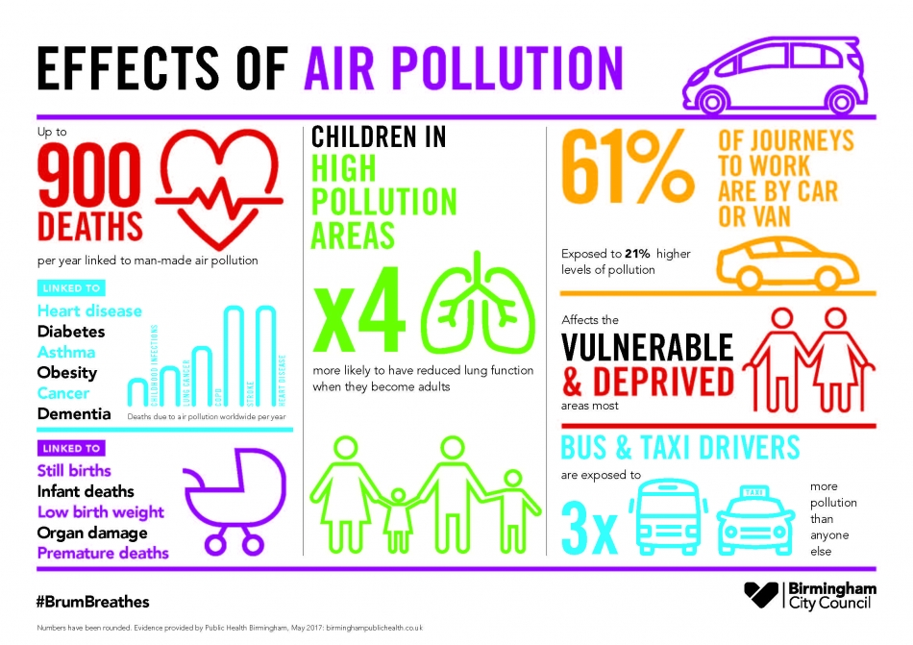
Lots more information here:
更多資料請見：
https://www.sustrans.org.uk/media/10493/west-midlands-walking-and-cycling-index2021.pdf
https://www.sustrans.org.uk/media/13263/birmingham-walking-and-cycling-index2023.pdf

Author’s conclusion: The evidence clearly shows that well designed projects in the right places that allow for more cycling and active travel can benefit physical, mental, environmental and financial wellbeing. Stopping such projects claiming that they are a waste of tax payers’ money and so on, is untrue and highly unhelpful. Our obsession with cars is fuelling the problem.
作者結論：證據清楚地顯示，在適當地點設計良好的腳踏車與主動交通設施，可以帶來身體、心理、環境和財務上的好處。說這些計畫是在浪費納稅人的錢是不正確也非常有害的。我們對汽車的執著正加劇這些問題。
Do you agree?
你同意嗎？
Look at the quotes and pictures below.
看看下面的引言和圖片。
What are they trying to say and how do you feel?
它們想表達什麼？你有什麼感覺？
“Either you’re part of the problem or you’re part of the solution.”
「你不是問題的一部分，就是解決方案的一部分。」
（一句出自 Harry Emerson Fosdick 的名言）
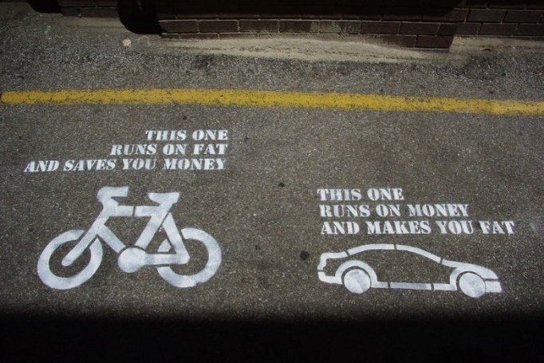
Original quote attributed to Peter Drew

ALLOCATION
OF
FUNDING
AND
ROAD
SPACE
Picture made using chat GPT & then added to by author
Quiz!
測驗!

True or false style quiz based on the information above
根據以上資訊的「是非題小測驗」

https://create.kahoot.it/details/1cd50c5e-f145-48f1-a1c3-854c31d0cd55

https://quizlet.com/gb/1035555628/the-value-of-bikes-bike-lanes-over-cars-roads-true-or-false-quiz-flash-cards/?i=5v19u&x=1jqt

